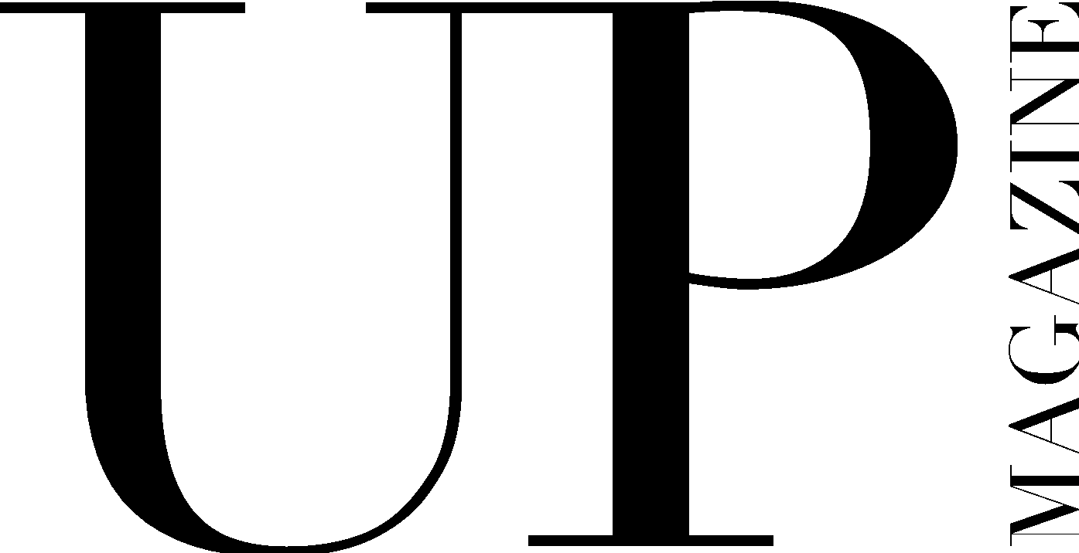

STAFF WRITER APPLICATION

UP Magazine is Miami University’s student-run fashion and lifestyle publication inspiring style and authenticity. UP Magazine is seeking talented, creative, committed, and driven student writers who are excited to be part of a collaborative and contemporary team.

The Staff Writer of UP Magazine is responsible for writing two articles throughout the year for print publication, brainstorming, researching, and conducting in-person (socially distanced with masks or virtual) interviews to produce content, attending all-staff meetings, writing team meetings and one-on-one writers conferences with editors.

Name:
Email:
Year:
Phone:
Major(s):
Minor(s):

Current on-campus involvement:

How much time can you commit to this position a week?

Related experience:

Why do you want to be a part of UP Magazine?

What makes you the ideal candidate for this position?

Are you familiar with AP style?

Where will you be taking Miami classes this semester?

Please include 2-3 examples of related work either in this application or attached in your email.

